Notes on CNN Training
- Implemented precision, recall, and F1-score metrics along with accuracy: Added Precision(), Recall(), and a custom F1-score (f1_m) to monitor performance more comprehensively.
- Trained on 50 epochs as opposed to the initial 25: Increased the training duration to 50 epochs to ensure the model has enough time to learn complex patterns.
- We implemented early stopping after 5 epochs with no improvement to avoid issues with overfitting: The EarlyStopping callback halts training when no improvement is observed in the validation F1-score for 5 epochs, preventing overfitting.
- Epoch 12 (val_f1_m = 15.9589) → This was the highest validation F1-score.
- Epoch 13 (val_f1_m = 15.7103) → The validation F1-score dropped.
- Since early stopping had patience=5, it means training continued for 5 more epochs after the best epoch (Epoch 8) without improvement: Early stopping monitored the F1-score, and the training was allowed to continue for an additional 5 epochs before stopping.
- Best epoch was epoch 8, so early stopping restored the weights from epoch 8: The model reverted to the weights from the epoch with the best F1-score (epoch 8).

Notes on Confusion Matrix (Initial Output)
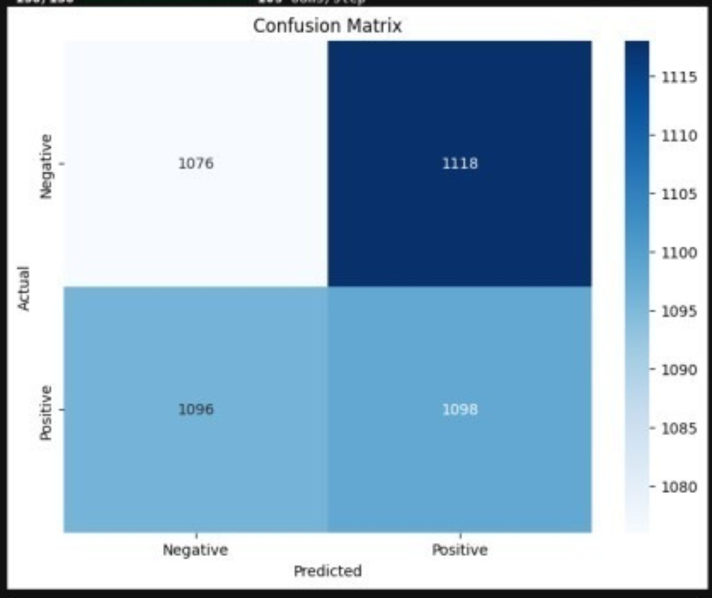
- True Negatives (TN) = 1076 → Model correctly classified these as Negative.
- False Positives (FP) = 1118 → Model incorrectly classified these as Positive.
- False Negatives (FN) = 1096 → Model incorrectly classified these as Negative.
- True Positives (TP) = 1098 → Model correctly classified these as Positive.

Observations
- High False Positives & False Negatives:
  - There are a significant number of misclassifications in both categories.
  - FP (1118) means that many actual negative samples are being misclassified as positive.
  - FN (1096) indicates that many actual positive samples are being misclassified as negative.
  - This suggests that the model might have trouble distinguishing between classes, possibly due to thresholding issues.

What Was Done

Preprocessing:
- Updated target size:
  - Changed the input image size from 64x64 to 128x128 in the ImageDataGenerator for training data (target_size=(128, 128)), providing higher resolution images for better feature extraction.
- Increased batch size:
  - Increased the batch size from a smaller value to 64 (batch_size=64) for better stability and efficiency during training.
- Data Augmentation for Training Set:
  - Added a variety of augmentations to increase the diversity of the training data:
    - rotation_range=20: Images can be rotated up to 20 degrees.
    - width_shift_range=0.2: Random horizontal shifts by 20% of the image width.
    - height_shift_range=0.2: Random vertical shifts by 20% of the image height.
    - shear_range=0.2: Shearing transformations applied to the image.
    - zoom_range=0.3: Random zoom with a range of up to 30%.
    - brightness_range=[0.8, 1.2]: Randomly adjust brightness within the given range.
    - horizontal_flip=True: Random horizontal flipping of images.
    - fill_mode='nearest': Fill gaps after transformation using the nearest pixel.

More Training:
- Used TensorFlow's built-in Precision() and Recall() for stability: Incorporated Keras' built-in Precision and Recall metrics to ensure consistent and reliable performance monitoring.
- Added Dynamic Thresholding (adjusted_threshold()) instead of fixed 0.5: Implemented a custom thresholding mechanism to adjust the decision threshold dynamically, providing more flexibility and better classification performance.
- Implemented Learning Rate Scheduling → Better optimizer convergence: The optimizer now uses a learning rate of 0.001 with L2 regularization (weight_decay=1e-5), which helps avoid overfitting and improves convergence.
- Added L2 Regularization (weight_decay=1e-5) to reduce overfitting: L2 regularization was added to penalize large weights, which helps the model generalize better to unseen data.

Notes on Confusion Matrix (Second Output)
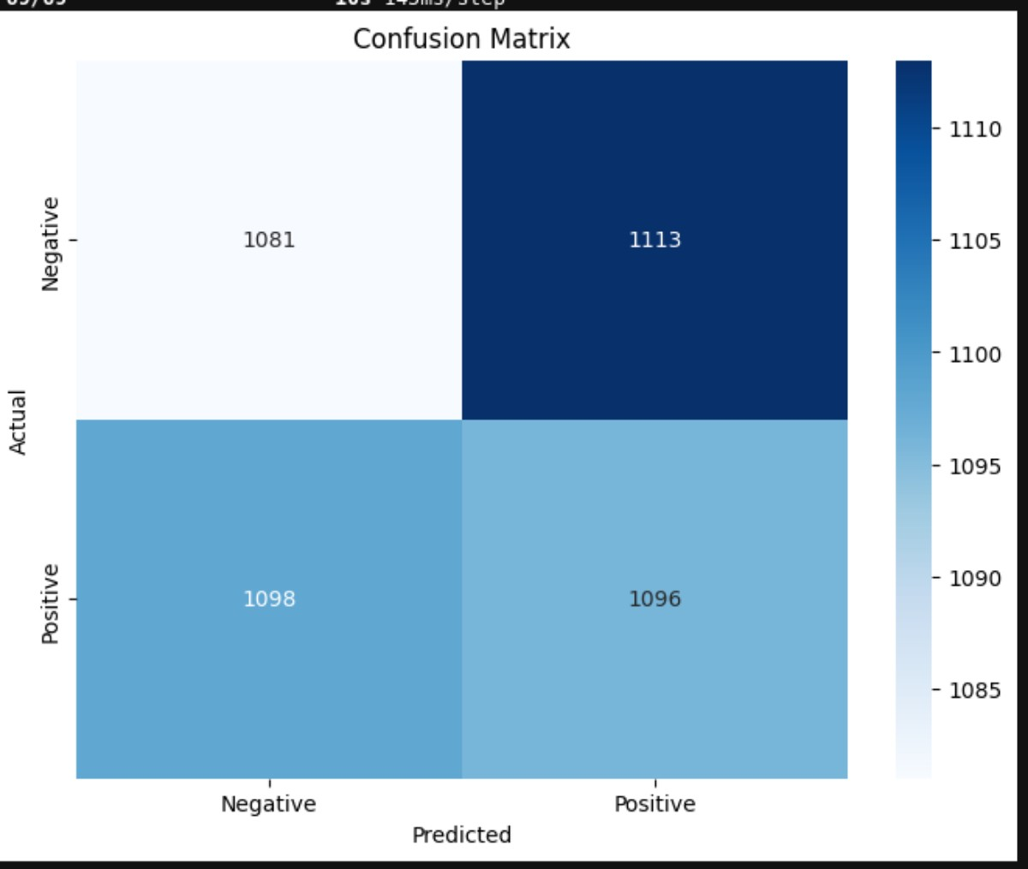

Observations:
- High False Positives (FP = 1113)
  - A large number of actual negatives are being misclassified as positive.
  - This could indicate a bias towards predicting the positive class too frequently.
- High False Negatives (FN = 1098)
  - Many actual positives are misclassified as negative.
  - The model struggles to distinguish between classes, affecting recall.
- Balanced TP and TN Counts
  - The model correctly identifies both positive and negative classes to a similar extent.
  - However, the misclassification rates are nearly equal, reducing overall model effectiveness.

What Was Done
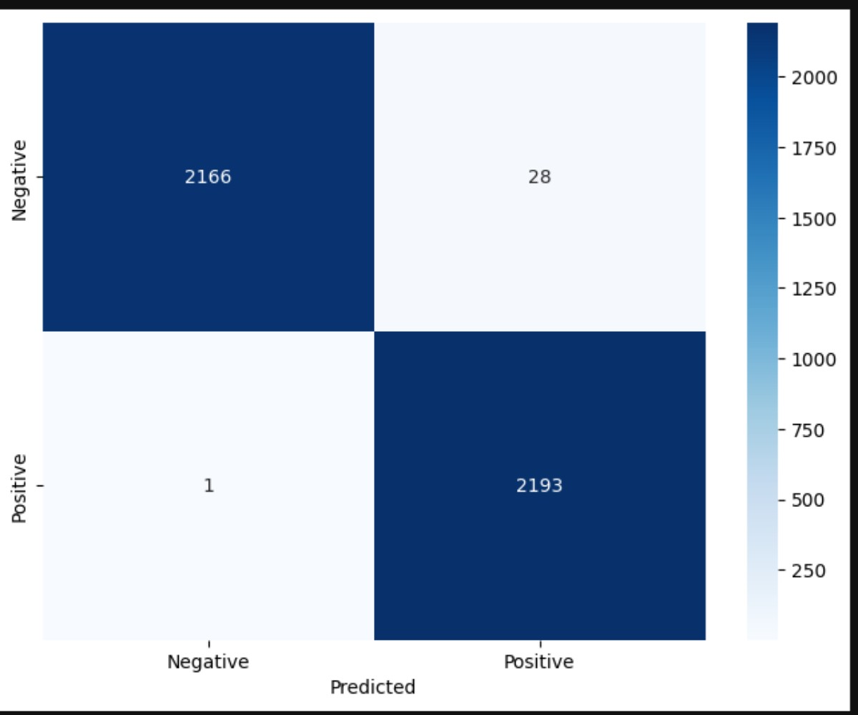
Tried a bunch of experimentation with tuning even increased batch sizes, did some coding to try and figure out the most ideal learning rate to improve F1.I even manual coded F1 function, nothing worked. So, I went back to initial model and just added the other metrics Ecil wanted basically started over after training all night. The F1 has been very problematic. Below is the best confusion matrix I got from my experiments, but then I nuked everything. I can’t get F1 over .50. This typically arises if the data sets are imbalanced but our data set is 100% balanced.

